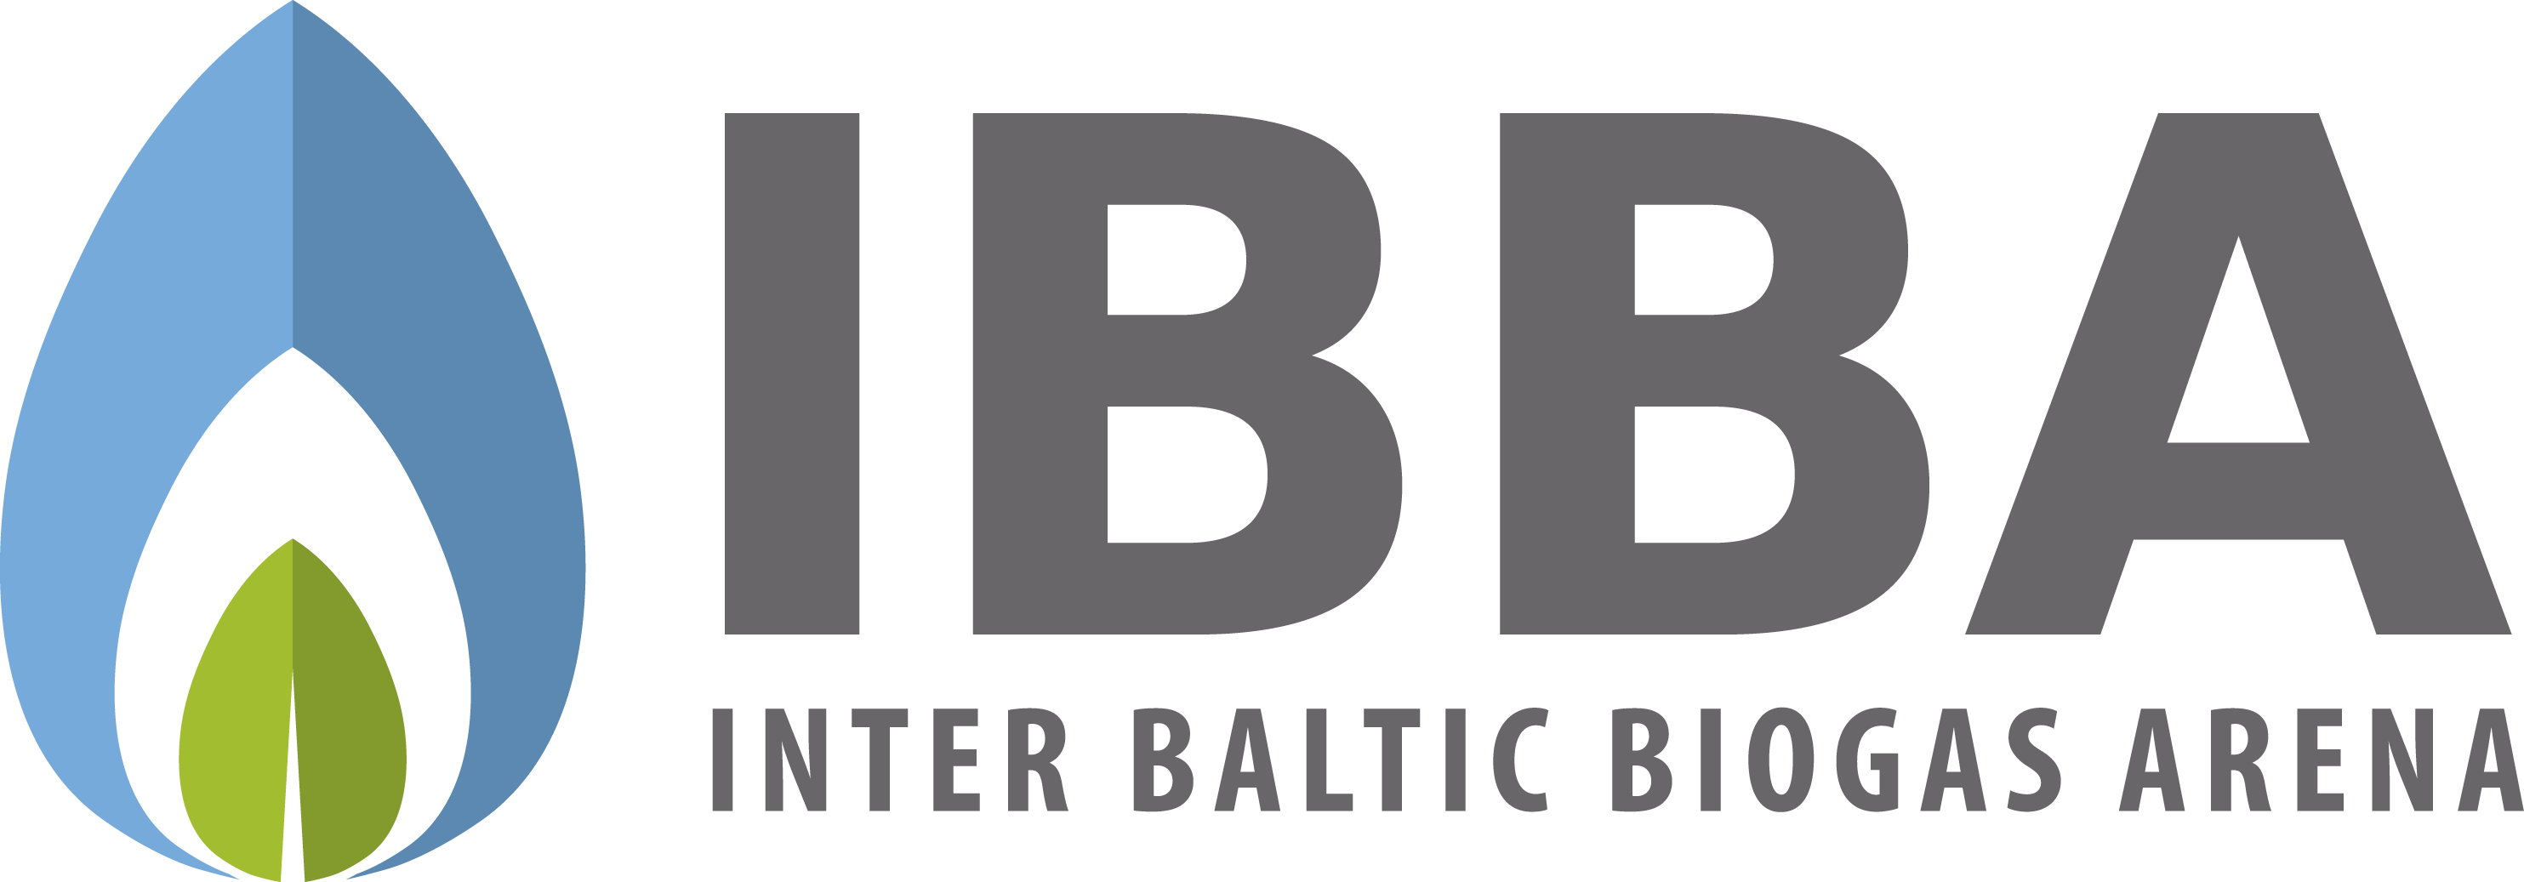

6th IBBA Workshop - Taking biogas branding to the next level

March 15th-16th, 2018

Stockholm, Sweden
The 6th IBBA workshop in Stockholm focuses on biogas branding. It gathers Europe’s leading branding initiatives in a setting aimed at creating a larger and more successful network for biogas communication in Europe.
Read more about the companies and organisations that will be there to share their experience and don’t miss this opportunity to not only meet them, but work together on creating new concepts.
Find out more! www.ibbaworkshop.eu

